**Goliath Application Availability Monitor Installation**

Application Availability

This article was updated to support v12.0.1 of Goliath Application Availability Monitor.

**Please note, if your configuration of Goliath Application Availability Monitor (GAAM) is integrated into Goliath Performance Monitor (GPM) this article is not applicable for your configuration. Please skip to the** [**Post Installation: What's Next?**](https://support.goliathtechnologies.com/hc/en-us/articles/360025157833-Goliath-Application-Availability-Monitor-Installation-#h_f8737f79-8bbf-4986-9aff-878c7e07bb6f) **section of this article or create a support ticket for further assistance.**

**Article Contents**

1. [Are You Ready to Install?](https://support.goliathtechnologies.com/hc/en-us/articles/360025157833-Goliath-Application-Availability-Monitor-Installation-#h_d00808f1-7f37-465c-83a0-5a2ef5bb85c3)
2. [Goliath Application Availability Monitor Installation Steps](https://support.goliathtechnologies.com/hc/en-us/articles/360025157833-Goliath-Application-Availability-Monitor-Installation-#h_4362906c-8ff1-4e07-821e-664ff7204d81)
3. [Post Installation: What's Next?](https://support.goliathtechnologies.com/hc/en-us/articles/360025157833-Goliath-Application-Availability-Monitor-Installation-#h_f8737f79-8bbf-4986-9aff-878c7e07bb6f)

**Are You Ready to Install?**

Before proceeding, please ensure you have the following items available and prepared:

1. Confirm that all applicable [Prerequisites](https://support.goliathtechnologies.com/hc/en-us/articles/360024625734) have been completed
2. Goliath Application Availability Monitor Installation file has been download
3. Your Goliath license key
   1. This should have been provided by Goliath Finance Department upon purchase.
   2. If you do not have your license key please submit a support ticket and a member of the team will look it up and send it over to you.

**Goliath Application Availability Monitor Installation Steps**

Click the appropriate link below to jump to the relevant installation steps for installing the Goliath Application Availability Monitor (GAAM) Server component.

* [Install Goliath & Connect to Remote Full SQL Server](https://support.goliathtechnologies.com/hc/en-us/articles/360025157833-Goliath-Application-Availability-Monitor-Installation-#h_01F366XQP9SXVY4BX562VFX0V8)
* [Install Goliath & Connect to Local Full SQL Server](https://support.goliathtechnologies.com/hc/en-us/articles/360025157833-Goliath-Application-Availability-Monitor-Installation-#h_01F366XWFHXY36DVRT15E7T999)
* [Install Goliath & Connect SQL Server manually](https://support.goliathtechnologies.com/hc/en-us/articles/360025157833-Goliath-Application-Availability-Monitor-Installation-#h_d4f16c38-3612-4714-aa8f-038f0041f505)
* [Install Goliath w/ Embedded SQL Express](https://support.goliathtechnologies.com/hc/en-us/articles/360025157833-Goliath-Application-Availability-Monitor-Installation-#h_3cc55161-8fb4-4c0b-90c0-cc2dcbc35562)
  + Proof of Concept & Product Evaluations please reference this section

**Install Goliath & Connect to Remote Full SQL Server**

The Setup program will install the Goliath Application Availability Monitor (GAAM) software on the system you want to be designated as the Goliath Server component. In addition, the installer will attach the goliath database to your remote SQL Server and grant the windows service account defined as a database owner. **Please note, the installer must be run as an account with sysadmin rights to the SQL Server.**

1. Connect to the system you want to be designated as the Goliath Server component (RDP or Console)
2. Ensure that the Server Role "Web Server (IIS)" **is not** already installed on the system.
   1. If it is, please uninstall the role and reboot the machine prior to continuing
3. Exit all programs
4. To install GAAM run the installer executable, **GoliathServer.exe,** as a user account with sysadmin rights to the SQL Server in which you will be connecting Goliath to
   1. If you need a copy of the installer, please open a support ticket
5. The executable will start the install process and display a Welcome installer
   1. 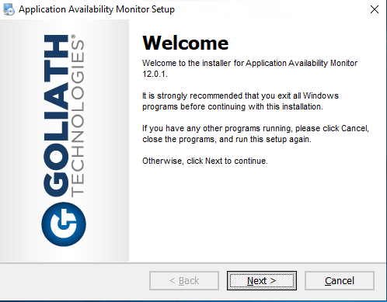
6. Click **Next** to view the End User License Agreement. Read the agreement and if you agree with the terms, select **I agree to the terms of this license agreement** and click **Next**. If you do not agree or do not wish to continue, select **I do not agree to the terms of this license agreement** and click **Cancel** to exit the installer
   1. 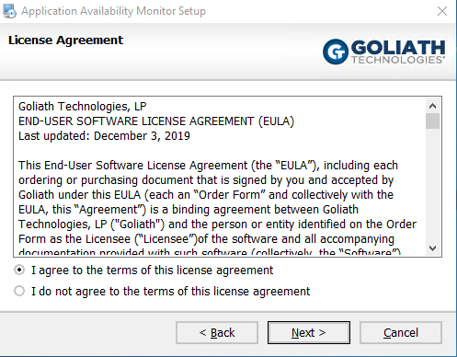
7. Enter your product license key provided by Goliath Technologies and select **Next** to continue
   1. 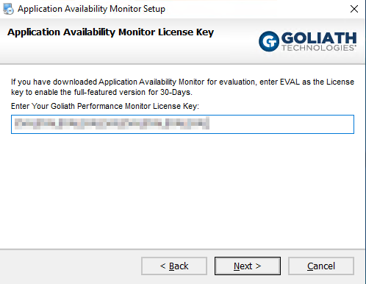
8. Please verify and or specify the **STATIC IP Address** or **DNS Name** for the Goliath Application Availability Monitor Server and Web Interface **Console Port**. When finished select **Next** to continue
   1. 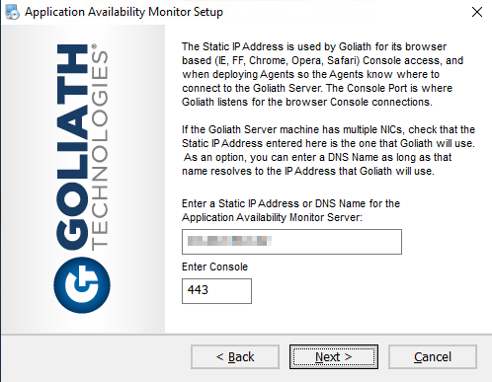
9. Once **Next** is selected, the wizard will verify that the **Console Port** is available. If it is, Goliath Application Availability Monitor will then continue
   1. 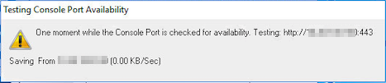
10. The next step lets you select where to install the Goliath Application Availability Monitor program. When the appropriate location is confirmed or entered, click **Next** to continue.
    1. The default location is **C:\Program Files\Application Availability Monitor.**
11. If this is a full installation with an **official license key,** you will see the following options for configuring the database settings. Choose the option for **Use existing Remote SQL Server.**
    1. 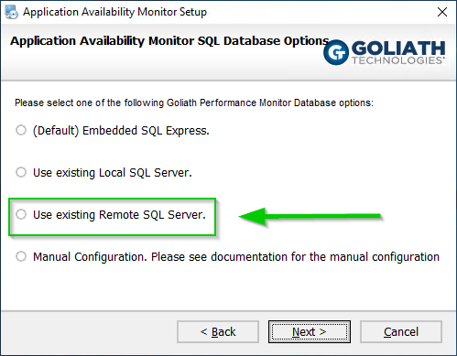
12. Next, define the configuration settings for the Remote SQL Server:
    1. Name of the SQL Server instance or Always On Availability Group where database will reside
    2. Name of the Goliath Database
       1. This is defaulted to GoliathDB but can be modified if desired
    3. Windows service account, in the format of **domain\user**, that has Windows Admin rights to the Goliath Server and will be given the database role membership of db_owner for on-going SQL connectivity.
    4. Credentials for the above user account
    5. 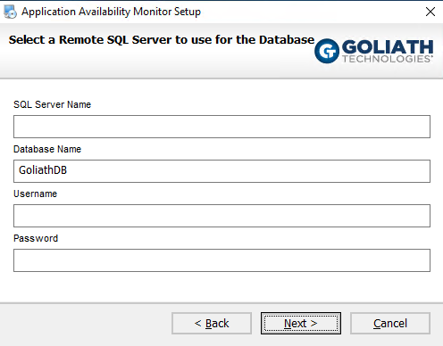
13. Please verify that the installation settings listed are correct, if so select **Next** to proceed with the installation or **Back** to make the appropriate modifications.
14. During the installation process, a progress bar will show the progress of installing the Goliath Application Availability Monitor, as seen in the figure below.
    1. 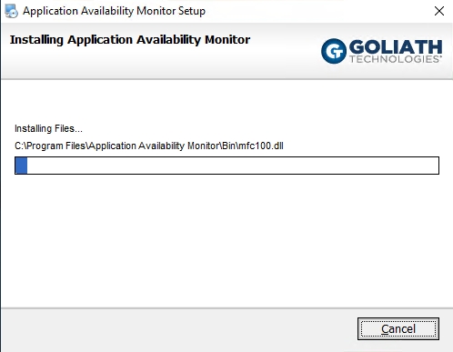
    2. **Please Note:**  At some points during the installation your screen may go blank. This is a normal part of the installation process.
15. Once Goliath Application Availability Monitor is successfully installed the install program will display a message that the installation is complete, Click **Finish** to exit the install program.
16. For the first time running Goliath post installation, you'll need to **launch the desktop icon** to open Goliath Application Availability Monitor
    1. Please note, the launch may take a few minutes as additional files and services are created at the products initial start-up

You have successfully installed Goliath Application Availability Monitor and can now launch the application and continue to the [Post Installation: What's Next?](https://support.goliathtechnologies.com/hc/en-us/articles/360025157833-Goliath-Application-Availability-Monitor-Installation-#h_f8737f79-8bbf-4986-9aff-878c7e07bb6f) below.

**Install Goliath & Connect to Local Full SQL Server**

The Setup program will install the Goliath Application Availability Monitor (GAAM) software on the system you want to be designated as the Goliath Server component. In addition, the installer will attach the goliath database to your local SQL Server and grant the windows service account defined as a database owner. **Please note, the installer must be run as an account with sysadmin rights to the SQL Server.**

1. Connect to the system you want to be designated as the Goliath Server component (RDP or Console)
2. Ensure that the Server Role "Web Server (IIS)" **is no**t already installed on the system.
   1. If it is, please uninstall the role and reboot the machine prior to continuing
3. Exit all programs
4. To install GAAM run the installer executable, **GoliathServer.exe,** as a user account with sysadmin rights to the SQL Server in which you will be connecting Goliath to
   1. If you need a copy of the installer, please open a support ticket
5. The executable will start the install process and display a Welcome installer
   1. 
6. Click **Next** to view the End User License Agreement. Read the agreement and if you agree with the terms, select **I agree to the terms of this license agreement** and click **Next.** If you do not agree or do not wish to continue, select **I do not agree to the terms of this license agreement** and click **Cancel** to exit the installer
   1. 
7. Enter your product license key provided by Goliath Technologies and select **Next** to continue
   1. 
8. Please verify and or specify the **STATIC IP Address** or **DNS Name** for the Goliath Application Availability Monitor Server and Web Interface **Console Port**. When finished select **Next** to continue.
   1. 
9. Once **Next** is selected, the wizard will verify that the **Console Port** is available. If it is, Goliath Application Availability Monitor will then continue.
   1. 
10. The next step lets you select where to install the Goliath Application Availability Monitor program. When the appropriate location is confirmed or entered, click **Next** to continue.
    1. The default location is **C:\Program Files\Application Availability Monitor.**
11. If this is a full installation with an **official license key,** you will see the following options for configuring the database settings. Choose the bottom option for **Use existing Local SQL Server**
    1. 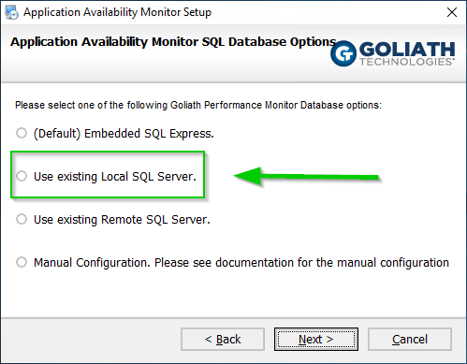
12. Next, define the configuration settings for the local SQL Server:
    1. Name of the SQL Server instance or Always On Availability Group where database will reside
    2. Name of the Goliath Database
       1. This is defaulted to GoliathDB but can be modified if desired
    3. 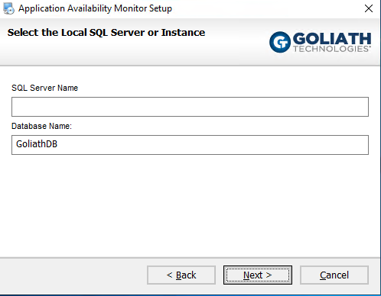
13. Please verify that the installation settings listed are correct, if so select **Next** to proceed with the installation or **Back** to make the appropriate modifications.
14. During the installation process, a progress bar will show the progress of installing the Goliath Application Availability Monitor, as seen in the figure below.
    1. 
    2. **Please Note:**  At some points during the installation your screen may go blank. This is a normal part of the installation process.
15. Once Goliath Application Availability Monitor is successfully installed the install program will display a message that the installation is complete click **Finish** to exit the install program.
16. For the first time running Goliath post installation, you'll need to **launch the desktop icon** to open Goliath Application Availability Monitor
    1. Please note, the launch may take a few minutes as additional files and services are created at the products initial start-up

You have successfully installed Goliath Application Availability Monitor and can now launch the application and continue to the [Post Installation: What's Next?](https://support.goliathtechnologies.com/hc/en-us/articles/360025157833-Goliath-Application-Availability-Monitor-Installation-#h_f8737f79-8bbf-4986-9aff-878c7e07bb6f) below.

**Install & Connect SQL Server manually**

The Setup program will install the Goliath Application Availability Monitor (GAAM) software on the system you want to be designated as the Goliath Server component. Additional steps are also included on how to connect Goliath to a SQL Server manually.

1. [Download](https://goliathpm.s3.amazonaws.com/Consulting/Database.zip) and extract the Goliath database mdf file
2. Place the Goliath database file on the SQL Server in the appropriate **DATA** Directory
3. Open SQL Management Studio and connect to the SQL Server
4. Attach the **GoliathDB** database to the SQL Server
   1. Note, the transaction log file will created upon attachment so you will have to remove it from the "database details" section during the attachment process
5. Once the database attachment is complete:
   1. Define a Windows Account that has **db_owner** rights to the database
   2. Make sure that the **GoliathDB** database is set to the highest compatibility level
6. Connect to the system you want to be designated as the Goliath Server component (RDP or Console)
7. Ensure that the Server Role "Web Server (IIS)" **is not** already installed on the system.
   1. If it is, please uninstall the role and reboot the machine prior to continuing
8. Confirm that the **db_owner** account for the database has local admin rights on the Goliath Server.
   1. It is suggested to sign into the Goliath Server as this account before proceeding further
9. Exit all programs
10. Install the latest version of the SQL Native Client which will be needed for the SQL Server connection.
    1. Here is a link to [version 11.0](https://s3.amazonaws.com/Software_ISOs/IT/sqlncli_11_0_70001_0-19Jan2018.msi) - this is a 2 min Next>Next install
11. To install GAAM run the installer executable, **GoliathServer.exe,** as a user account with **sysadmin** rights to the SQL Server in which you will be connecting Goliath to
    1. If you need a copy of the installer, please open a support ticket
12. The executable will start the install process and display a Welcome installer
    1. 
13. Click **Next** to view the End User License Agreement. Read the agreement and if you agree with the terms, select **I agree to the terms of this license agreement** and click **Next**. If you do not agree or do not wish to continue, select **I do not agree to the terms of this license agreement** and click **Cancel** to exit the installer
    1. 
14. Enter your product license key provided by Goliath Technologies and select **Next** to continue
    1. 
15. Please verify and or specify the **STATIC IP Address** or **DNS Name** for the Goliath Application Availability Monitor Server and Web Interface **Console Port**. When finished select **Next** to continue.
    1. 
16. Once **Next** is selected, the wizard will verify that the **Console Port** is available. If it is, Goliath Application Availability Monitor will then continue.
    1. 
17. The next step lets you select where to install the Goliath Application Availability Monitor program. When the appropriate location is confirmed or entered, click **Next** to continue.
    1. The default location is **C:\Program Files\Application Availability Monitor.**
18. If this is a full installation with an **official license key,** you will see the following options for configuring the database settings. Choose the bottom option for **Manual Configuration**
19. 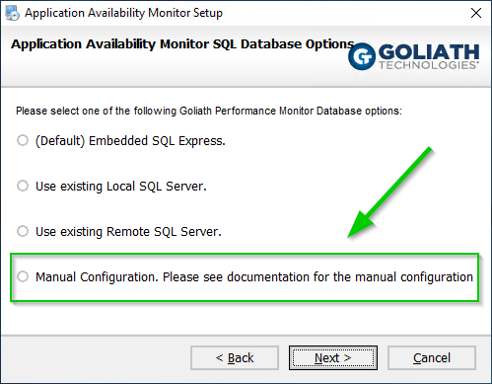
20. Please verify that the following installation settings are correct, if so select **Next** to proceed with the installation or **Back** to make the appropriate modifications.
21. During the installation process, a progress bar will show the progress of installing the Goliath Application Availability Monitor, as seen in the figure below.
    1. 
    2. **Please Note:**  At some points during the installation your screen may go blank. This is a normal part of the installation process.
22. Once Goliath Application Availability Monitor is successfully installed the install program will display a message that the installation is complete click **Finish** to exit the install program.
    1. Now that the installation is finished, there are a few more steps that need to be completed in order to connect Goliath & SQL.
    2. 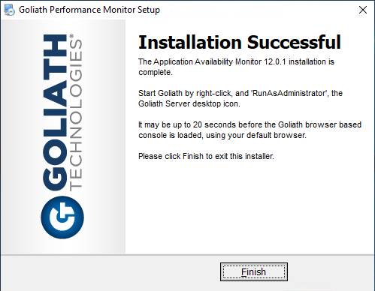
23. Right click the desktop icon for Goliath Application Availability Monitor and **run as admin**
    1. Upon click you will see the below, this is expected, click ok and proceed.
24. Launch Windows Services and stop the **MonitorIT Server Service**
25. Launch **ODBC Data Sources (64-bit)** from Windows Administrative Tools
26. When **ODBC Data Sources (64-bit)** launches, by default it will be on the **User DSN** tab. Switch to the **System DSN** tab
27. You will see an entry listed named **BreakoutRPM**, select it and click the **Configure** button
    1. If there is not an entry listed, please create one via Add>SQL Server Native Client 11.0
28. Update the **Server** field with the SQL Server and instance name where the database resides then choose **Next**
29. Keep all default settings on the **How should SQL Server verify...** page and click **Next**
30. Update the field **Change the default database to:** to the name of the Goliath database.
    1. If the checkbox for **attach database filename** is checked, please uncheck it and then click **Next**
    2. The default name is **GoliathDB** but check the SQL Server to be sure it wasn't customized.
31. Keep all default setting on the following page and click **Finish**
32. A SQL Server Setup window will appear. Click the **Test Data Source...** button to confirm the SQL Connection is successful. Then click **OK** to save the configuration.
    1. Please note, if your user account doesn't have rights to the SQL Server and database it is ok if the test fails.
33. Now that the DSN is updated, feel free to close the ODBC Data Source application by clicking OK.
34. Open Windows File Explorer and navigate to the **\Application Availability Monitor\Database** folder
    1. Default location is **C:\Program Files\Application Availability Monitor\Database**
35. Edit the file **DatabaseVersioningTool.exe.config** with the following settings and save once complete
    1. On line 4, replace the **data source=localhost** setting with **data source=____** where the blank is the SQL Server and instance name of where the database resides (what was entered in step 29).
       1. For example, if your database resides at SQL\Test12 then it should be data source=SQL\Test12
    2. On line 4, replace the **initial catalog=MonitorIT1** setting with **initial catalog=____** where the blank is the name of your database.
       1. For example, if your database name is GoliathSB then it should be initial catalog=GoliathDB
36. From Windows Files Explorer, within the **\Application Availability Monitor\Database** folder go to File>Open Windows Powershell as administrator
37. A Powershell console window will open, enter the command **.\DatabaseVersioningTool.exe** and click the enter key
    1. For this step, be sure that the account you are running this as has SQL Server sysadmin rights
38. The Powershell console window will prompt you to **Please Enter Go to Continue**, type **Go** and hit the enter key to proceed
39. The database will now be upgraded to match the current version of the product installed
    1. If you get any errors back, please reference the **migration.log** file in the **Database** folder.
       1. More often then not the error is due to permissions or network connection. Please resolve the issue and try steps 36-39 again. Feel free to open a support ticket for additional assistance if needed
40. Open Windows Services and right click the **MonitorIT Server Service** and go to **Properties**
41. Go to the **Log On** tab
42. Change the **Log on as** option to be **This account** and then enter the username and password of the SQL db_owner account
43. Click **Apply** and then **OK** to save the setting.
44. Start the **MonitorIT Server Service**
45. Within 3-5 mins, if you refresh the Windows Services screen, you should now see another service called **MonitorIT Agent Service**. Once you see that service created you can launch the technology and and continue to the next section.

You have successfully installed Goliath Application Availability Monitor and can now launch the application and continue to the [Post Installation: What's Next?](https://support.goliathtechnologies.com/hc/en-us/articles/360025157833-Goliath-Application-Availability-Monitor-Installation-#h_f8737f79-8bbf-4986-9aff-878c7e07bb6f) below.

**Install w/ Embedded SQL Express**

The Setup program will install the Goliath Application Availability Monitor (GAAM) software and SQL Express 2017 on the system you want to be designated as the Goliath Server component. **Please note, SQL Express is not recommended for medium/large deployments of Goliath as there is a 8-10GB data retention limitation.**

1. Exit all programs
2. To install Goliath, run the downloaded executable, **GoliathServer.exe**
   1. To retain of copy of the latest installer, please open a support ticket.
3. The executable will start the install process and display a Welcome installer
   1. 
4. Click **Next** to view the End User License Agreement. Read the agreement and if you agree with the terms, select **I agree to the terms of this license agreement** and click **Next**. If you do not agree or do not wish to continue, select **I do not agree to the terms of this license agreement** and click **Cancel** to exit the installer
   1. 
5. Enter your product license key provided by Goliath Technologies and select **Next** to continue. For Proof of Concept & Product Evaluations, keep the default license key of **EVAL** and select Next to continue.
   1. 
6. Please verify and or specify the **STATIC IP Address** or **DNS Name** for the Goliath Application Availability Monitor Server and Web Interface **Console Port**. When finished select **Next** to continue.
   1. 
7. Once **Next** is selected, the wizard will verify that the **Console Port** is available. If it is, Goliath Application Availability Monitor will then continue.
   1. 
8. The next step lets you select where to install the Goliath Application Availability Monitor program. When the appropriate location is confirmed or entered, click **Next** to continue.
   1. The default location is **C:\Program Files\Application Availability Monitor**
   2. 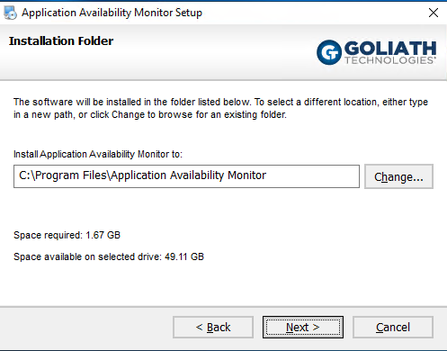
9. For Proof of Concept & Product Evaluations, please proceed to the next step. If this is a full installation with an **official license key,** you will see the following options for configuring the database settings. Choose the top option for **(Default) Embedded SQL Express.**
   1. 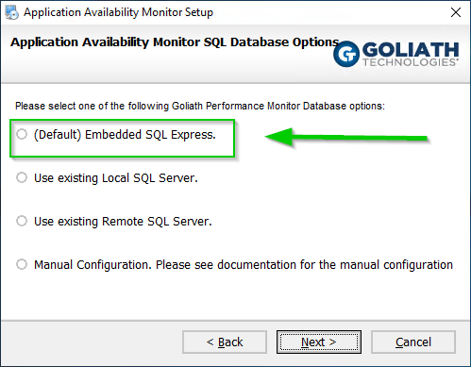
10. Please verify that the following installation settings are correct, if so select **Next** to proceed with the installation or **Back** to make the appropriate modifications.
    1. 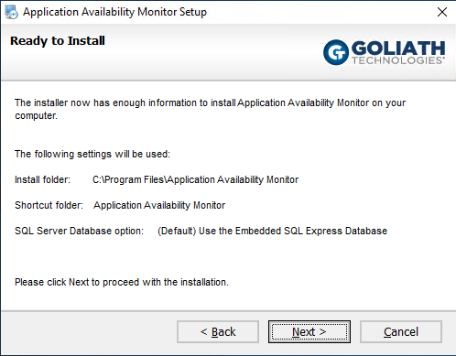
11. During the installation process, a progress bar will show the progress of installing the Goliath Application Availability Monitor, as seen in the figure below. You will also see the installation of the SQL Express database installation take place if applicable.
    1. 
    2. **Please Note:**  At some points during the installation your screen may go blank. This is a normal part of the installation process.
12. Once Goliath Application Availability Monitor and SQL Express, if applicable, are successfully installed the install program will display a message that the installation is complete click **Finish** to exit the install program.
    1. 
13. For the first time running Goliath post installation, you'll need to **launch the desktop icon** to open Goliath Application Availability Monitor
    1. Please note, the launch may take a few minutes as additional files and services are created at the products initial start-up

You have successfully installed Goliath Application Availability Monitor and can now launch the application and continue to the [Post Installation: What's Next?](https://support.goliathtechnologies.com/hc/en-us/articles/360025157833-Goliath-Application-Availability-Monitor-Installation-#h_f8737f79-8bbf-4986-9aff-878c7e07bb6f) below.

**Post Installation: What's Next?**

In the following article, we will discuss the details for configuring the Application Availability Monitor post install. This includes how to prepare your GAAM Launch Endpoint to allow launches to execute, how to configure the simulations, and how to schedule them to run successfully.

**NOTE**: If your instance of Goliath Application Availability Monitor is integrated with Goliath Performance Monitor, for POC purposes the Launch Endpoint can be the same as the Goliath Server, but for full implementations we do recommend that the instances stay separate.

1. [Launch Endpoint Installation & Configuration](https://support.goliathtechnologies.com/hc/en-us/articles/360024769993)
2. [Configure the Launch Schedules](https://support.goliathtechnologies.com/hc/en-us/articles/360025158873)
3. [Launch Endpoint Maintenance](https://support.goliathtechnologies.com/hc/en-us/articles/360046852254)
4. [GAAM Reporting](https://support.goliathtechnologies.com/hc/en-us/articles/360024498514)
5. [Understanding the Launch Results](https://support.goliathtechnologies.com/hc/en-us/articles/360024496374)